Voltage Amplifier

Analyzed, Constructed, & Written by Chris Vasquez

Table of Contents

1. **Summary**………………………………………………….……….…1
2. **Introduction**………………………………………………………….2

*Procedure*……………………………………………………….….…2

*Analyses Types*…………………………………………….………….2

1. **Voltage Amplifier Overview**………………………………….…….4
2. **PSPICE & Performance Analyses**…………………………….........6

*DC Analysis*…………………………………………………….…..…6

*Temperature Analysis*……………………………………………...…8

*Transfer Function Analysis*……………………………………….…10

*Sensitivity Analysis*……………………………………….………….11

*Monte Carlo Analysis*……………………………………………….13 *Transient Analysis*………………………………………………...…14

*AC Analysis*…………………………………………………….……17

1. **Specifications**……………………………………………………….19

*Chosen Components*………………………………………….…..….19

*Manufacturing & Pricing*………………………………………....…20

1. **Conclusion**………………………………………..…………………22

# Summary

For this project we were meant to construct an audio amplifier. However, my partner decided to give up on this course and was unable to complete his half of the amplifier. Therefore, I will be presenting my designed voltage amplifier. Additionally, as a way to compensate for the sudden change in design, I have attached an output jack to the design to connect to an offboard current amplifier. Connecting said amplifier to my designed voltage amplifier will allow for a two-stage amplifier to be constructed, meaning it can potentially be used as a full audio amplifier.

Throughout the designing of this voltage amplifier, much research needed to be conducted, as my knowledge on bipolar junction transistors was quite limited. However, despite this learning curve, I was able to analyze and construct a voltage amplifier with the usage of tools such as PSPICE and Eagle PCB. As we will see through the various PSPICE simulations mentioned in this report, the designed voltage amplifier is optimal in performing its job. In the aspects of gain, bandwidth, and overall quality, the amplifier delivers high performance. However, it should be noted that the cost of this amplifier is rather high, as that design and part quality comes with a cost. Additionally, we are manufacturing our board through OSH Park, as their process of sending a PCB design is the simplest, having scripts written specifically for EAGLE to simplify the process.

Our goal in building this amplifier was not only to provide the basic functionality of amplifying voltage but to also do this function as best we could. In “manufacturing” these amplifiers, I am aiming to provide quality as opposed to quantity.

~ Chris Vasquez

# Introduction

## Procedure

As mentioned in the summary, much testing and simulation was conducted in order to ensure that the amplifier worked properly and up to standards. In order to demonstrate the amplifier’s performance and overall functionality, we will be mainly reviewing each performed simulation and analysis conducted on the voltage amplifier. In addition to these depictions of performance, this report will also discuss the functionality of each component, the parts chosen, the overall specs, and, lastly, the manufacturing cost.

## Analyses

DC Analysis: This analysis will first consist of a bias point simulation which will allow us to measure the voltages, currents, and power at each node/branch within the circuit for DC voltage conditions. Through this analysis we can see the base, collector, and emitter voltages and see how our circuit behaves at maximum DC voltage capacity. Additionally, this analysis will also consist of a DC Sweep analysis which will allow us to see our circuits behavior as DC voltage increases/decreases. Such a simulation is important in seeing how our amplifier behaves as the 9V dissipates in voltage, as the source will be batteries.

Temperature Analysis: In conducting this analysis, we can observe both the DC and AC performance of our circuit under various temperature. Additionally, this analysis gives us the chance to use our temperature coefficients obtained from our chosen resistor parts to receive a more accurate reading of our circuit performance in the real world.

Transfer Function Analysis: Performing this analysis, we can obtain the Thevenin equivalent voltage, input resistance, and output resistance. Each of these values are important because they tell us the various voltage and resistance rating of our amplifier. These values are especially helpful in our case, as they help us see the resistance and voltage of each stage, allowing us to better understand the effects of connecting the two amplifier stages together and their compatibility.

Sensitivity Analysis: Through this analysis we can measure the change in a given value, i.e. current, voltage, etc., at a specific point in the circuit under DC conditions, seeing how unit/percentage variations in true-component values affects said measured value. This analysis is important in determining tolerances of components and the amount of value variation each component can have before the circuit malfunctions.

Monte Carlo Analysis: This type of analysis predicts the behavior of a circuit statistically when a part’s values are varied within their tolerance. This type of analysis can be useful in deciding what tolerance one should consider when buying given parts or manufacturing a given product.

Transient Analysis: Through this analysis we will see the input and output voltages of the circuit over a period, allowing us to gauge the amount of amplification our circuit is performing. Through this analysis we can also see the amount of gain our circuit is outputting.

AC Analysis*:* By performing an AC analysis, we will be able to not only see the gain of our amplifier, but also the bandwidth of it also. These parameters are important in determining our amplifier’s overall amplification and frequency response.

# Voltage Amplifier Overview

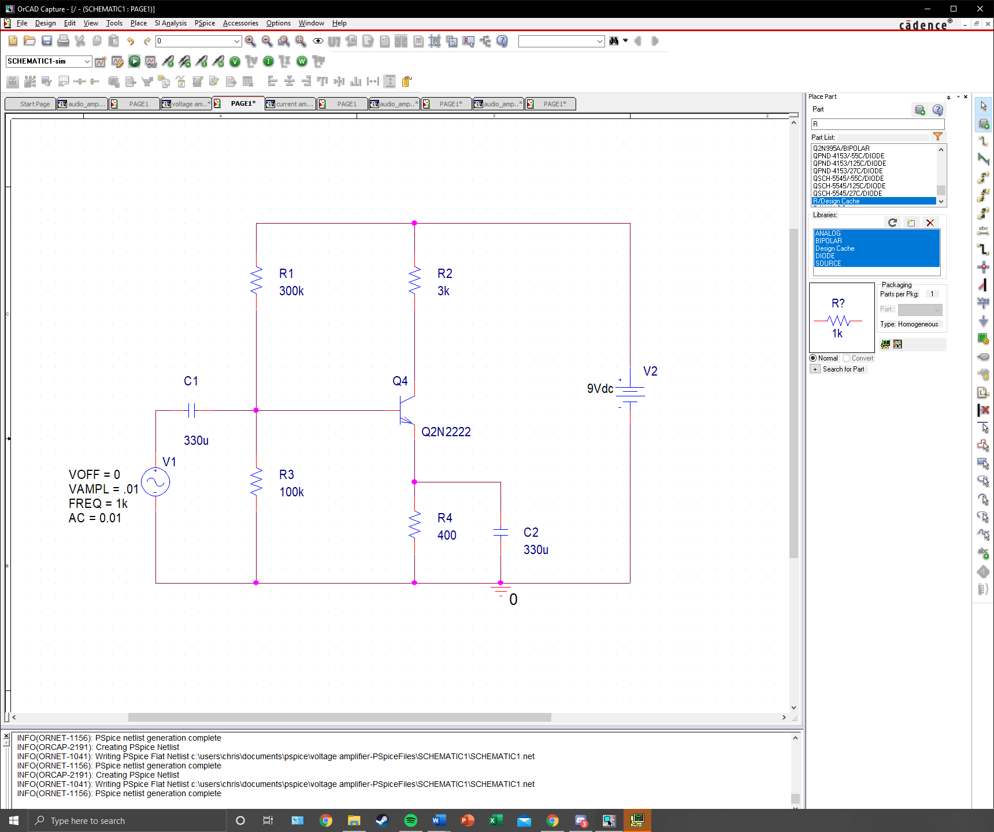

Fig. 1: BJT Voltage Amplifier with Feedback Resistor and Bypass Capacitor

Being the first stage of the complete amplifier, this stage focuses on voltage amplification. In this circuit capacitor C1 serves as a coupling capacitor which allows the AC signal to pass but blocks DC. It also protects the microphone’s coil from receiving a DC current from the amplifier’s bias current and protects the amplifier’s bias circuit and protects the amplifier’s bias circuit from being disturbed by the impedance of the microphone. Capacitor C1 transmits the voltage fluctuations from the microphone, superimposing them upon the bias voltage between the bias resistors of R1 and R3. Both these resistors form a voltage divider and establish a voltage-divider bias for the base of transistor Q4. From a 9V power supply, R3 will develop roughly 1V which is enough to forward bias the base junction of Q4, allowing the transistor to turn ON.

BJT Q4 is the heart of this common-emitter voltage amplifier. The transistor’s main job is to transform variations in the base current caused by the microphone voltage variations arriving over C1 into current variations through the collector-emitter circuit. The resistor R2 acts as the load for the collector-emitter amplification stage. Variations in the current controlled by Q4 cause R3 to develop a voltage; it should be noted that this voltage is the output of the voltage amplifier. Additionally, the voltage is inverted with respect to the microphone signal. When the signal is positive, more current flows through R2, developing a greater voltage drop. Since the top of R2 is connected to the 9V source, there is more voltage drop when the signal at the bottom of R2 is negative.

The emitter resistor R4 provides feedback to stabilize the DC bias of Q4. The bias provided by R1 and R3 turns on Q4 using a voltage of about 1V, as we had previously noted. This bias causes current to flow through the transistor and this same current causes a voltage in R4 to develop. In addition to this resistor, capacitor C2 by passes the R4 resistor for AC signals. The R4 resistor has the effect of feedback. The amplified current passes through R4 and develops a voltage while Q1 “rides” on this same voltage. The voltage being amplified is the difference between the input and the emitter; therefore, R4 provides negative feedback, which reduces gain. By introducing C2, we rid of this feedback for AC signals. We should note that AC signals do not experience negative feedback, meaning the gain is much higher for these signals. R2 and R4 provide a stable DC bias for the BJT Q4, and capacitor C2 allows us to “go around” this bias, creating a higher gain for AC. Since the microphone will input a small signal, a large amount of voltage gain is needed, which is mostly provided by this first stage of the amplifier.

# Voltage Amplifier: PSPICE Analyses

## DC Analysis

*Note: In performing this analysis, the branch containing the AC source and capacitor C1 will have no current flowing through it and can be ignored (reference Fig. 1 for described branch).

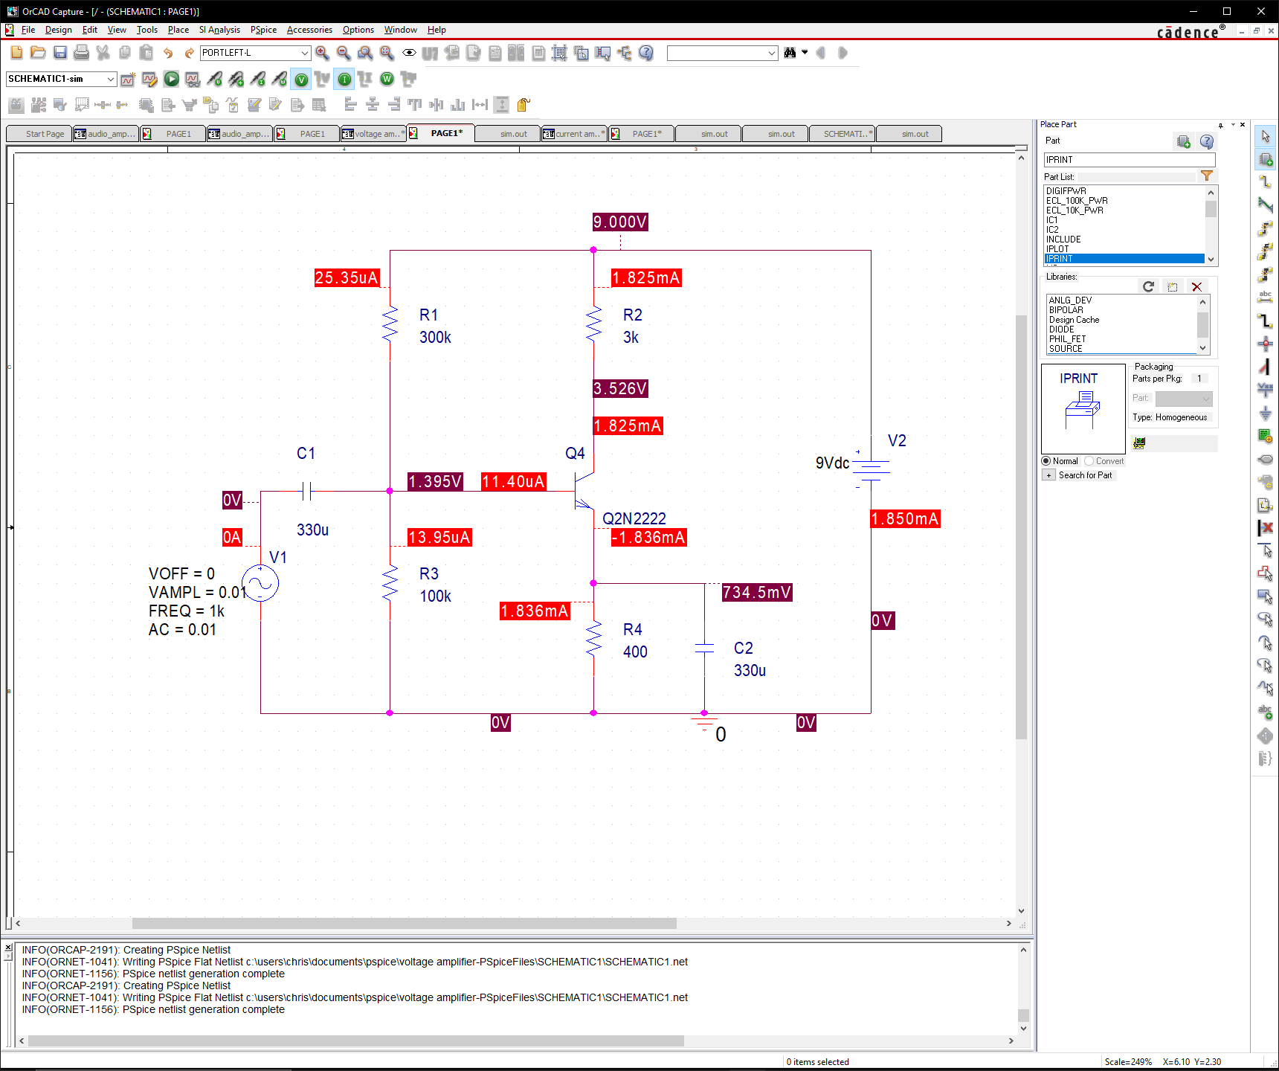

Fig. 2: Bias Point Simulation of Voltage Amplifier

To begin our analysis, we first conducted a bias point simulation in order to see the voltages and currents going through the circuit at a max voltage of 9V. If we refer to Fig. 2, we can notice the following values:

These values act as the max voltages and currents when our amplifier has a full 9V supplied to it. One of the most important values to note is the collector voltage, as this is our output voltage for our voltage amplifier. Additionally, any variation away from these values of voltage and current will result in a decrease in performance of our amplifier. To see said decrease, we can perform a DC sweep analysis and see the collector voltage’s value as the DC source loses voltage.

Looking at Fig. 3, we can see that from a peak of 3.526V at 9V DC, the voltage amplifier’s output slowly decreases; however, at approximately 3V DC, the amplifier’s output starts to decrease more rapidly. So long as the battery voltage stays above 3V DC, the amplifier’s output voltage will not decrease any more than 1V. Keeping this fact in mind, we can say that our amplifier will function of 2/3 of its battery supply before complete functionality is lost.

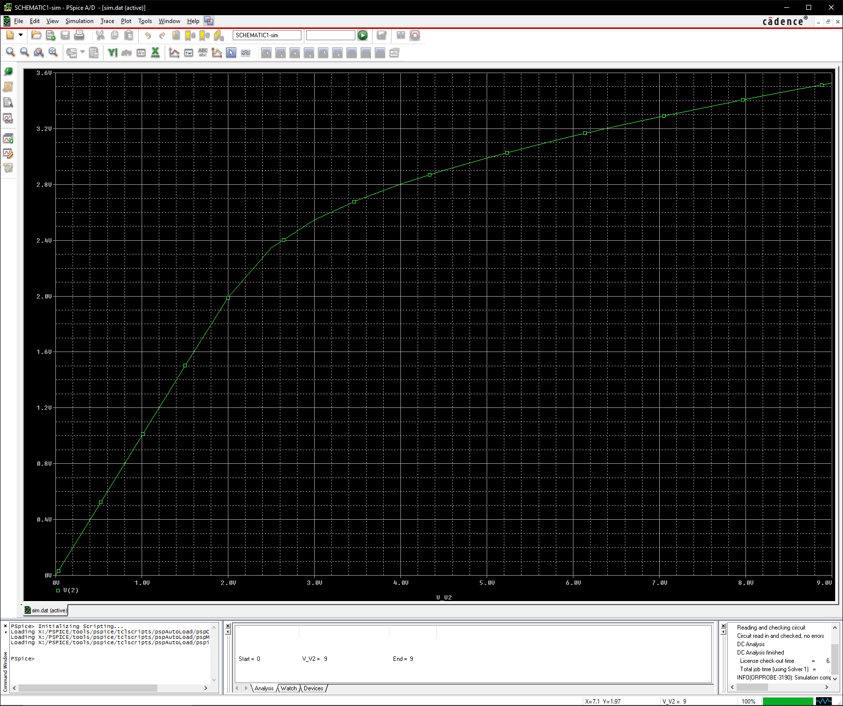

Fig. 3: DC Sweep Analysis of V2 DC source from 0V to 9V

## Temperature Analysis

For the first segment of this analysis, we measured the DC—meaning we will turn the AC voltage source OFF for this part of the analysis—collector voltage of the amplifier for temperatures 25, 75, and 150 degrees Celsius. We should also note that we have included the temperature coefficients for each resistor in the circuit to make our temperature analysis more accurate.

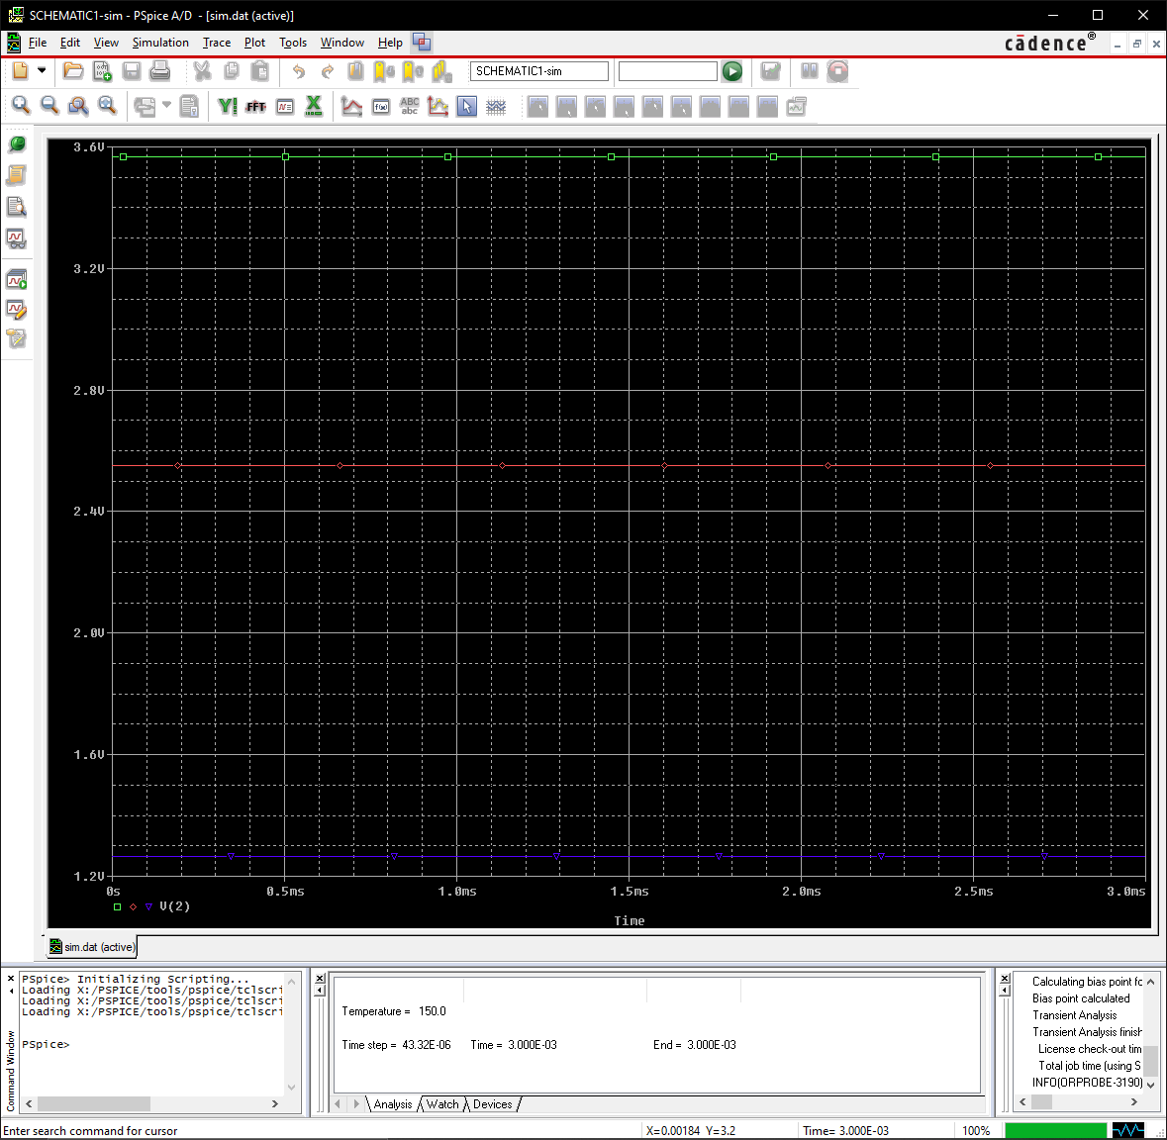

Fig. 4: DC Collector Voltages at 25, 75, and 150 Degrees Celcius (from Top to Bottom)

Looking at Fig. 4, we can see that as temperature increases, the DC collector voltage (output voltage) decreases. More specifically, looking at the graph gives us the following values for the following temperatures:

Given that the the temperatures of 150 degrees celius are extremes for our amplifiers, we can expect to avoid the drastically high temperatures such as 150 degrees celcius. Therefore, we can say that our circuit’s overall voltage response under DC considtions is rather good, as less than 1V is lost at 75 degrees celcius. It should be noted that if our amplifier were to reach 150 degrres celcius under real world conditions, we would have bigger problems than voltage gain decrease. In such a case, however, a heat sync can easily be used to reduced such performance.

Continuing this analysis, we had also looked at the effect of temperature on voltage gain under AC conditions. Unlike the previous part, we will now turn ON the AC input.

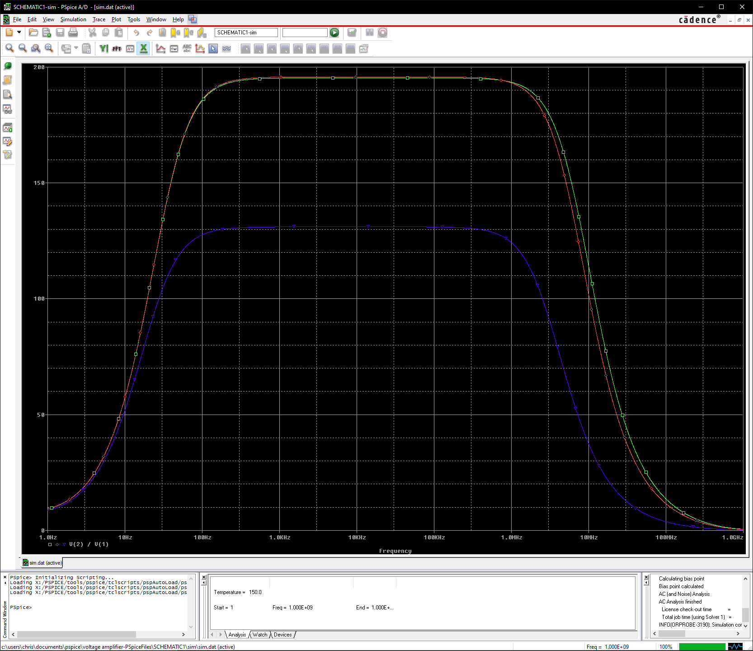

Fig. 5: Votage Gain at 25, 75, 125 Degrees Celcius (Top to Bottom)

Looking at Fig. 5, we can notice that the difference in voltage gain between the temperatures 25 and 75 degrees celcius is quite negligible, as the voltage gain itself is almost the same. However, there is a slight decrease in bandwidth as the temperature reaches 75 degrees celcius. Moreover, when the amplifier reaches 175 degrees celcius, there is a msssive drop in voltage gain (from 195.328 to 131.1 to be exact) Additonally, the frequency response for higher frequencies decreases quite significantly. However, since the decrease in bandwidth is based on the upper bound of the bandwidth, which covers frequencies we cannot hear, the decreases should not effect our amplifier’s bandwidth performance for our purposes.

## Transfer Function Analysis

*Note: In performing this analysis, the branch containing the AC source and capacitor C1 will have no current flowing through it and can be ignored (reference Fig. 1 for described branch).

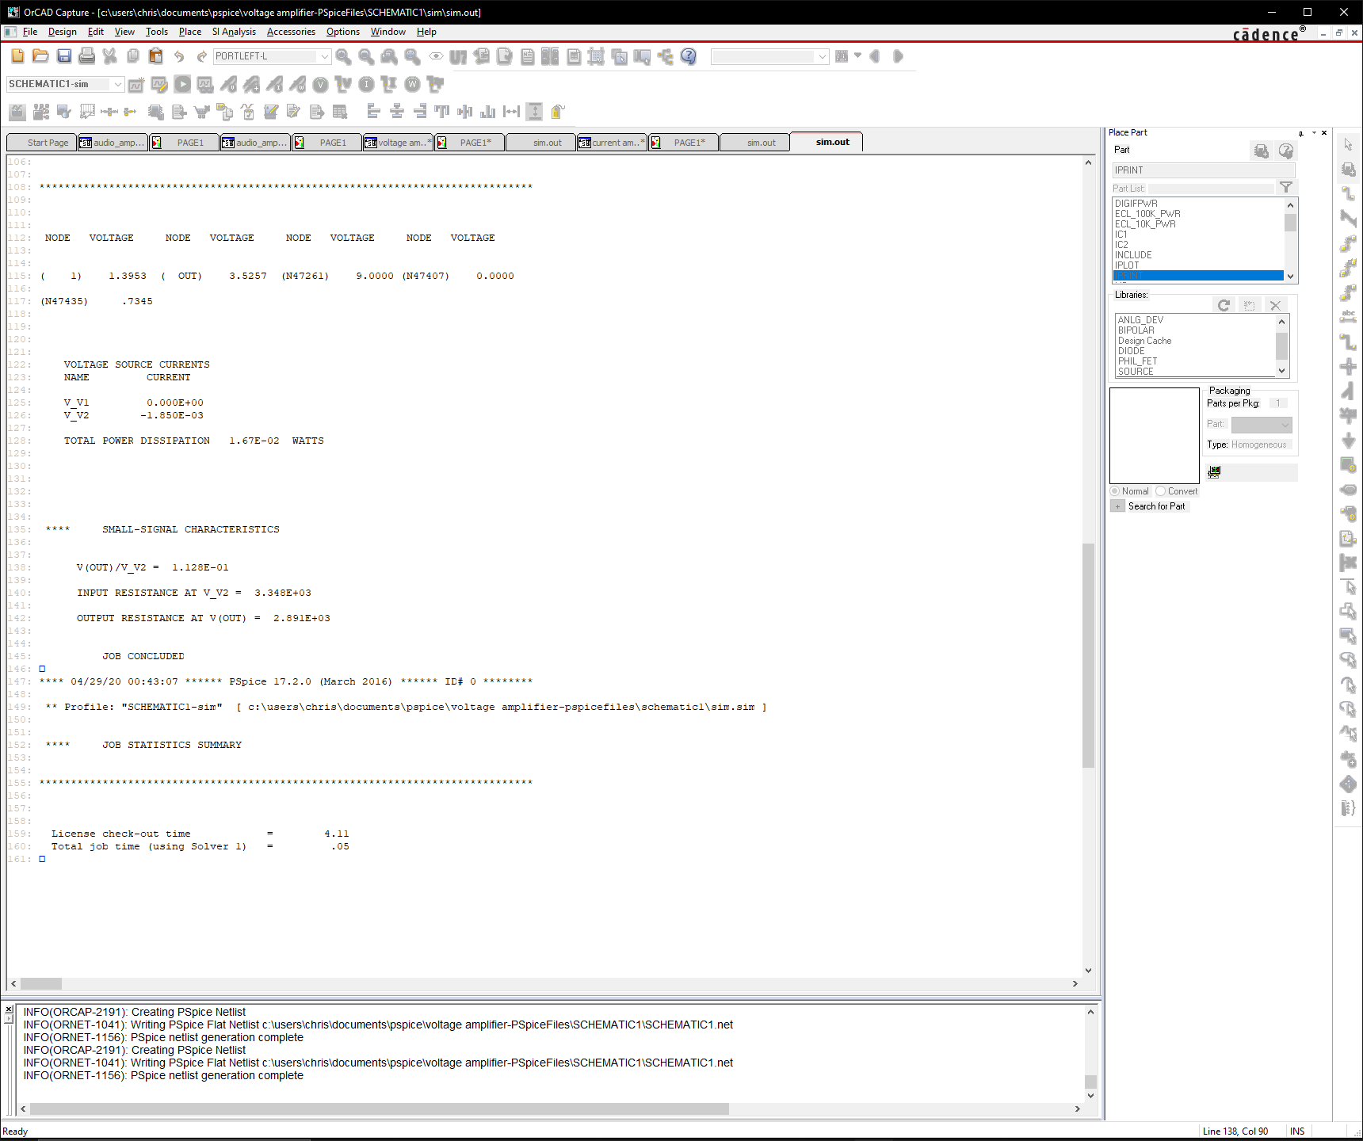

Fig. 6: Output File’s Calculated Thevenin Resistances and Voltage

Looking at the analysis results in Fig. 6, we can gather the following data:

From these values, we can know that our amplifier has an output voltage rating of 0.1128 V under DC conditions along with an output Thevenin resistance of 2.891kΩ and input Thevenin resistance 3.348kΩ. These values will serve as useful when connecting our voltage amplifier to a separate current amplifier, as they will tell us the resistance and voltage that we will be connecting to our voltage amplifier under DC conditions. These specifications are important to note about our voltage amplifier for that reason.

## Sensitivity Analysis

*Note: In performing this analysis, the branch containing the AC source and capacitor C1 will have no current flowing through it and can be ignored (reference Fig. 1 for described branch) Additionally, the capacitor C2 will also be ignored.

Given that we are dealing with a voltage amplifier, we are mainly concerned with the effect of component value variation on the overall output voltage, i.e. the collector voltage.

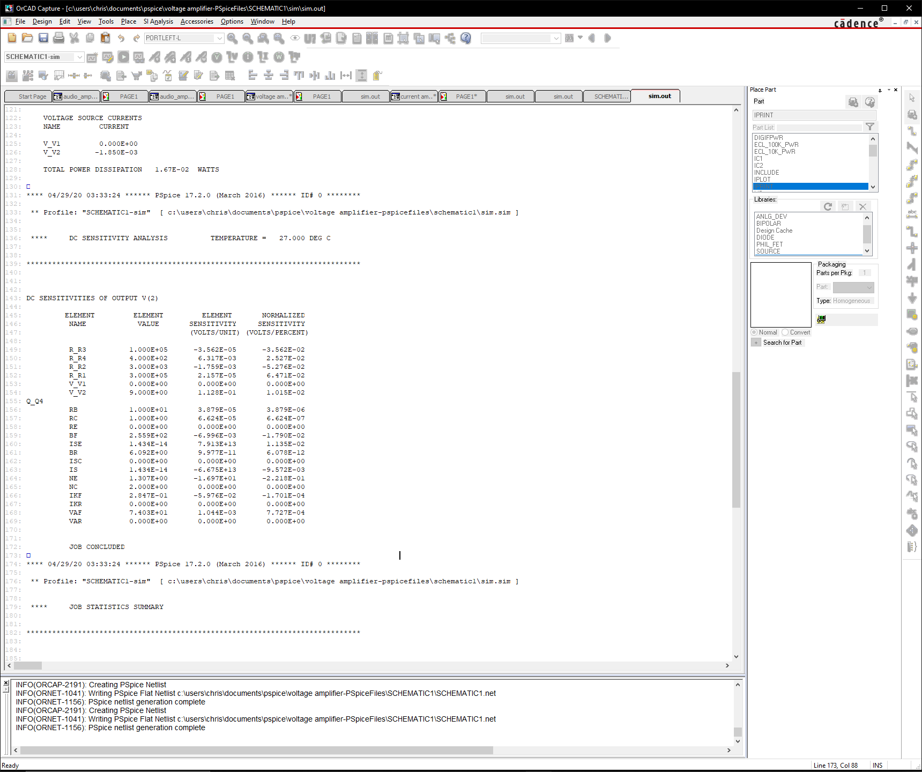

Fig. 7: Output File’s Sensitivity Analysis Results

Looking at Fig. 7 we can notice that the overall variance in output current regarding both element and normalized sensitivity is relatively large. If we look at resistor R1 specifically, which has the highest magnitude of normalized sensitivity, we can see that at a +10% tolerance, the resistor will differ the output voltage by no more than +0.647V, increasing the overall voltage output. However, on the contrary, if the tolerance swings to -10%, our output voltage would be negatively impacted, being decreased by 0.647V. Given that the passive elements are all resistors under this analysis, we must take into consideration the tolerance of resistors in order to ensure that we do not drastically affect the voltage output with high resistor tolerances. In addition to these tolerance considerations, we must also note that all these sensitivities will be affecting the output voltage simultaneously, meaning the variation away from an ideal output voltage can be vary greatly. Therefore, in order to be safe, we decided to choose small tolerances of 0.1% on our resistors to avoid any drastic changes in output voltage. As seen in the next analysis section, these resistors will help limit the range of variations as resistor values vary.

As a side note, since tolerances for resistors are measured using percentages, the normalized sensitivity column would be the most useful in choosing parts. Ideally, we would like the choose resistors with the lowest tolerances; however, in manufacturing these amplifiers, if we can get away with using higher tolerance resistors—which are usually cheaper—without affecting our amplifier’s performance, choosing the higher tolerance resistors would be more favorable.

## Monte Carlo Analysis

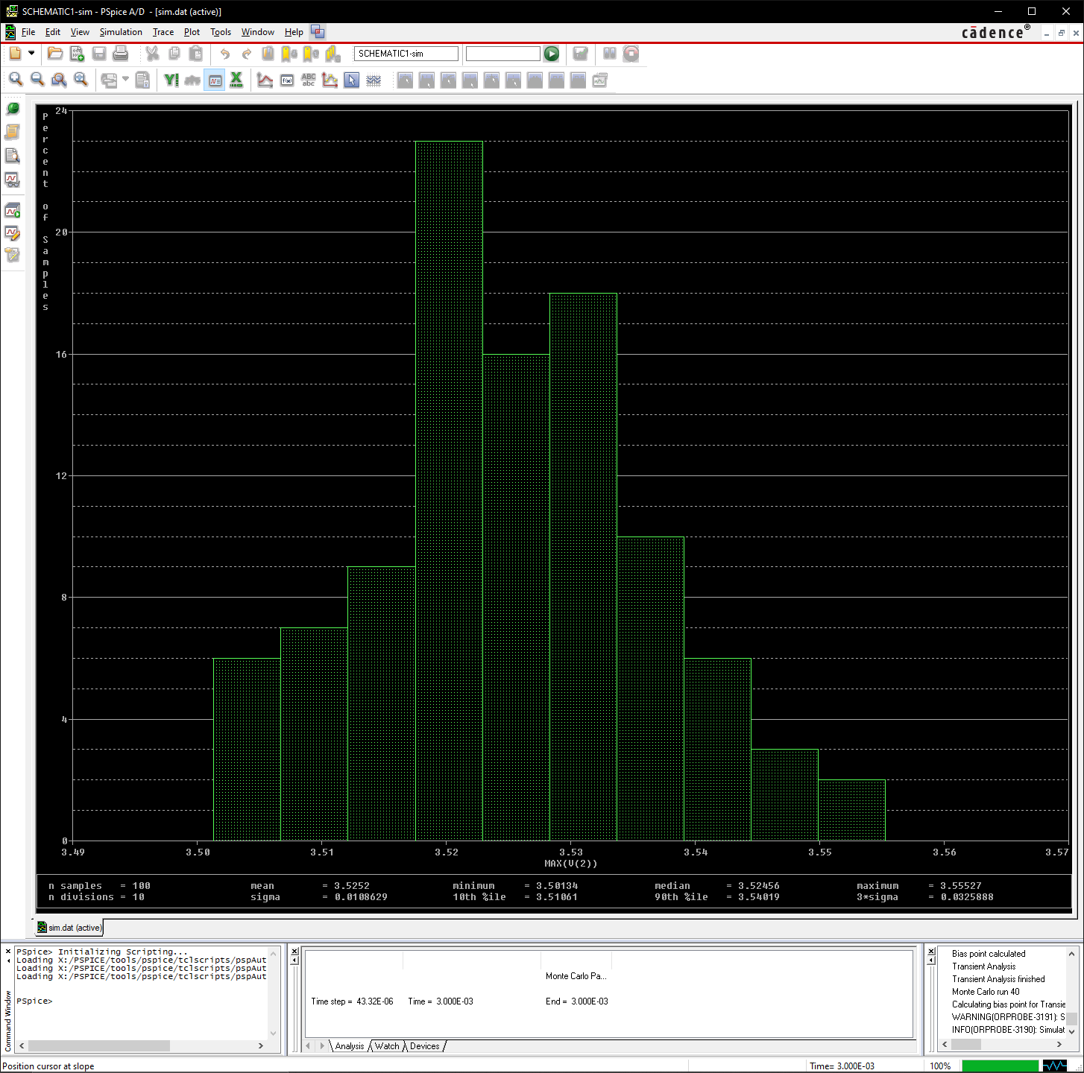

Fig. 8: Monte Carlo Analysis of Output

Having input the various tolerances for each resistor in PSPICE, we were able to generate Fig.8 which depicts the probability of the output voltage’s value based on a range of resistor values within each resistor’s given tolerance. Looking at Fig. 8, we can see that the most likely output voltage based on our chosen parts is 3.52V which is quite good, as the maximum is 3.56V. However, even if the most likely value is in our favor, there is still the probability that one of our manufactured amplifiers possesses only 3.50V. Considering that the difference in the most probable value is only 0.2V, our circuit’s overall range in its predicted voltages is quite small, being only from 3.50 to 3.55V. Given that our chosen resistors’ tolerances are 0.1%, this consistency in output voltage is expected from this analysis.

## Transient Analysis

For the voltage amplifier, we will be measuring the base and collector voltages, i.e. the voltages at nodes 1 and 2, respectively, as denoted by the Fig. 9.

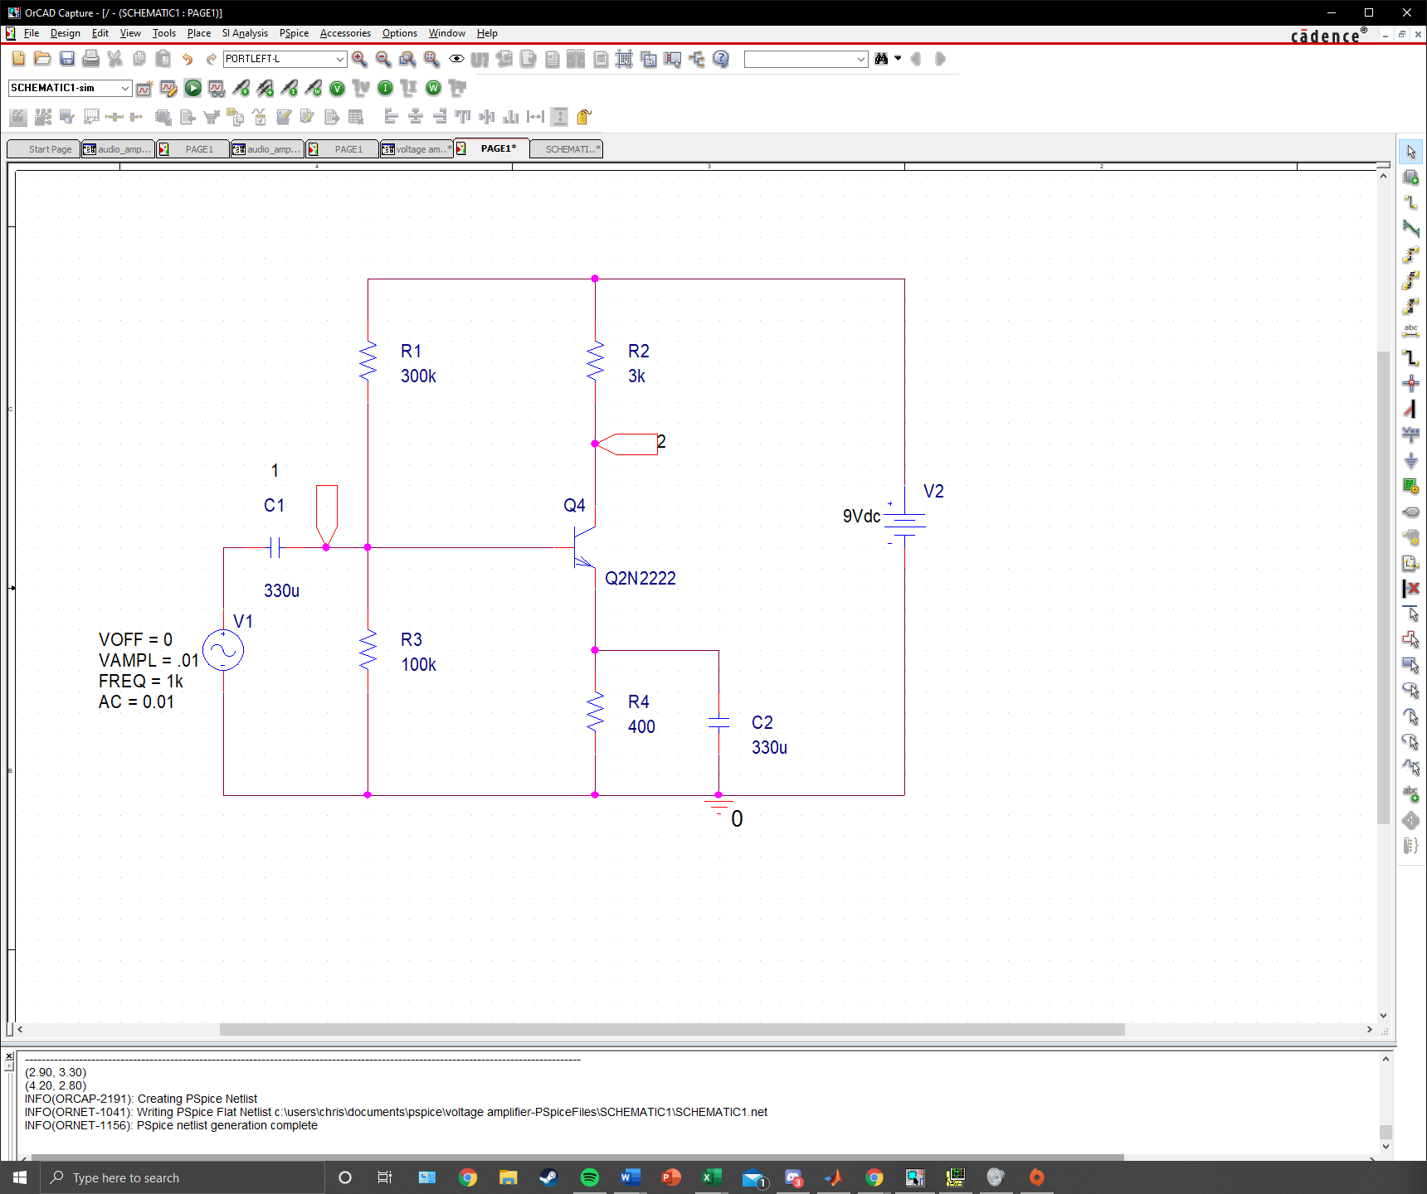

Fig. 9: Voltage Amplifier with Ports at Base and Collector of BJT

These voltages serve as the input voltage (with some DC offset) and output voltage of our voltage amplifier. If we look at Fig. 10a below, we can see that the base voltage possesses some DC offset as expected. This offset to positive voltages—with a range of 1.38V to 1.4V—allows us to ensure that our BJT is always forward biased. We should note that base voltage waveform remains at 0.02 Vpp as with the small signal input, as we have not amplified the wave yet. If we look at the collector voltage, however, we will notice that the range of voltages has increased to 1.31V to 5.24V, giving the output signal a Vpp of 3.93. If we compare the base voltage to the collector voltage, we can see a clear amplification between the two signals. Additionally, in the time domain, our gain can be measured to vary between 1.7679m to 3.7799 as seen in Fig. 10b. Using these same observed waveforms from Fig. 10a, we can produce a graph of gain. We will cover more on the voltage amplifier’s gain in the next section where we will perform an AC sweep Analysis of the amplifier, calculating its bandwidth.

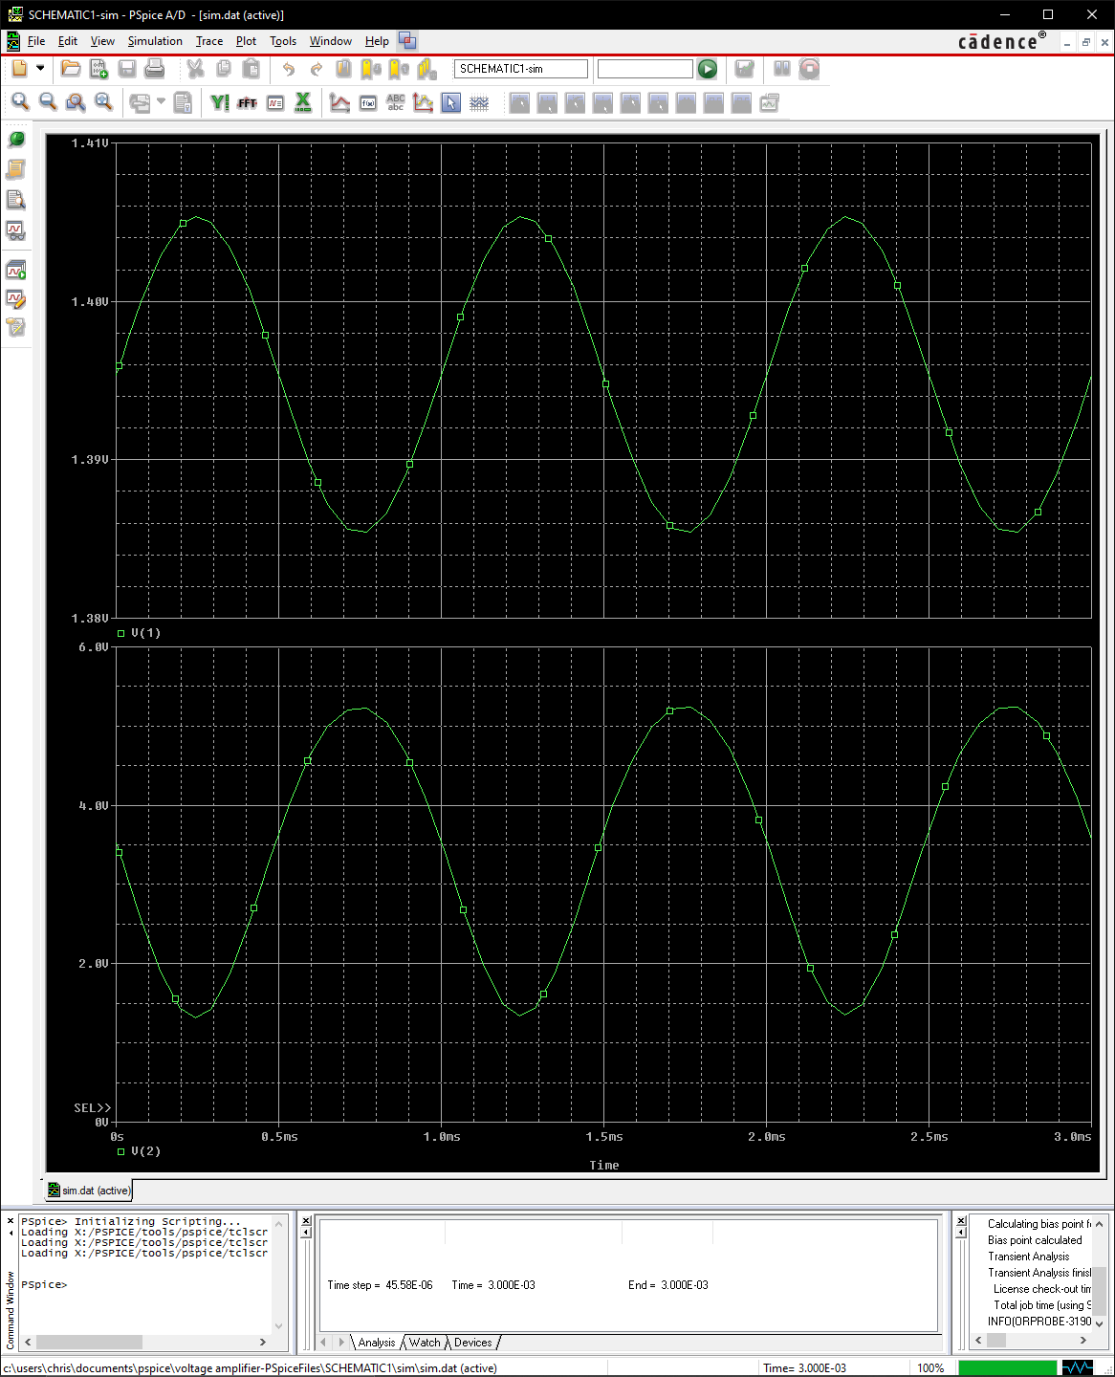

Fig. 10a: Base Voltage (Top Plot) and Collector Voltage (Bottom Plot) of Voltage Amplifier for 3ms

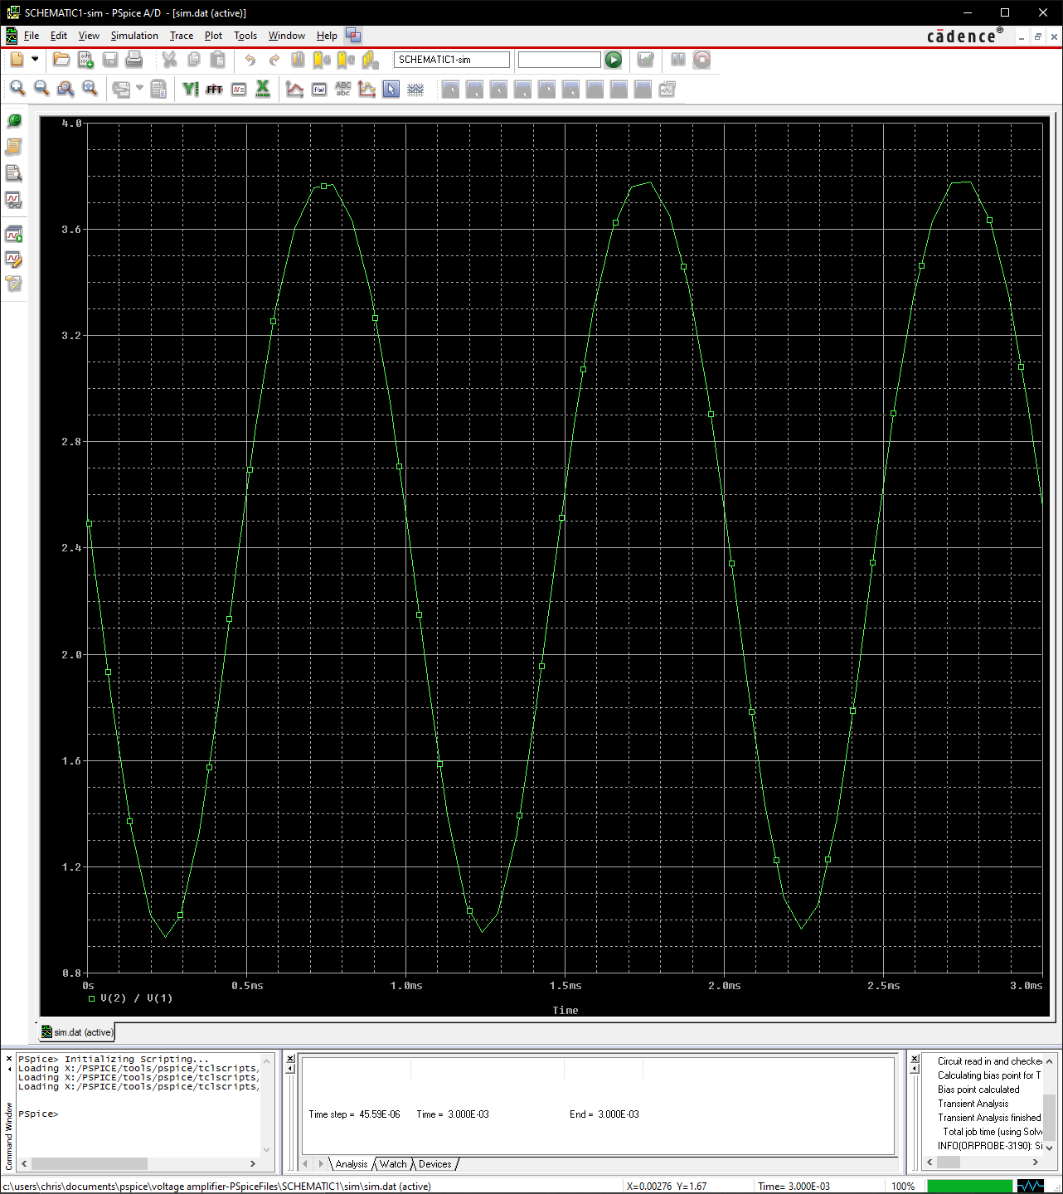

Fig.10b: Variation of Gain in the Time Domain for 3ms

In addition to amplification, however, we must also note that the max input voltage of V1 is 0.01V, as anything higher will begin to distort/clip the output signal. Fig. 11 depicts clipping in the output signal when the input AC voltage is 0.02V.

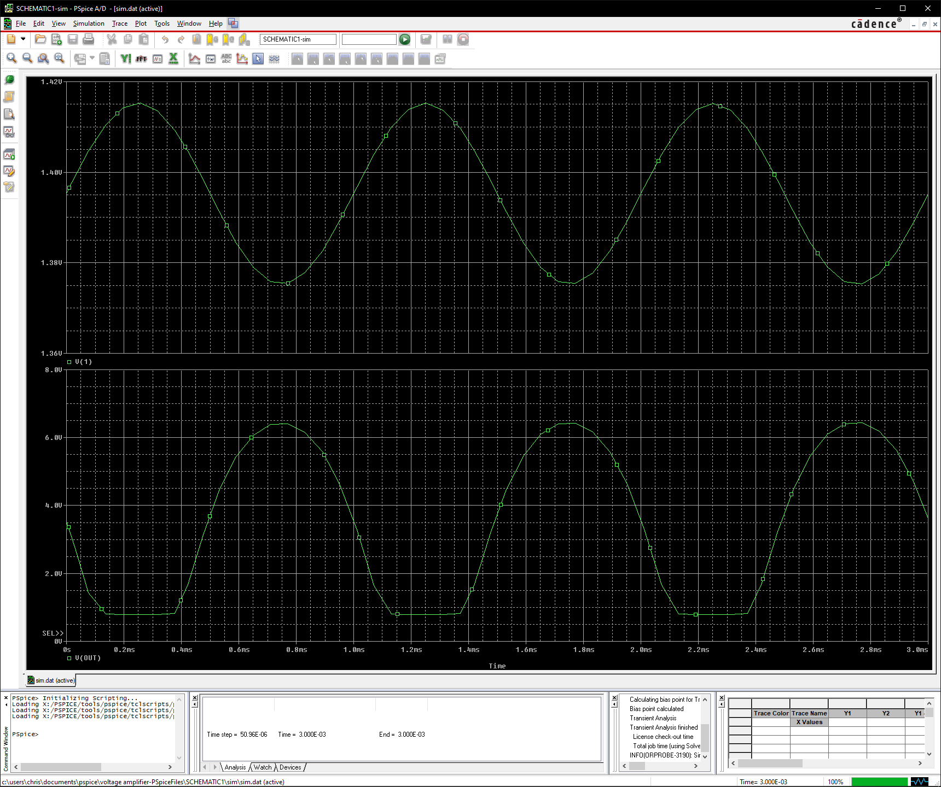

Fig. 11: Base Voltage (Top Plot) and Collector Voltage (Bottom Plot) of Voltage Amplifier for 3ms Experiencing Distortion with V1 = 0.02V

## AC Analysis

Using the equation:

we can easily calculate the gain our circuit and plot it with respect to frequency. Looking at Fig. 12, we can see that the overall max gain of our amplifier is approximately 195.394, or 45.818dB.

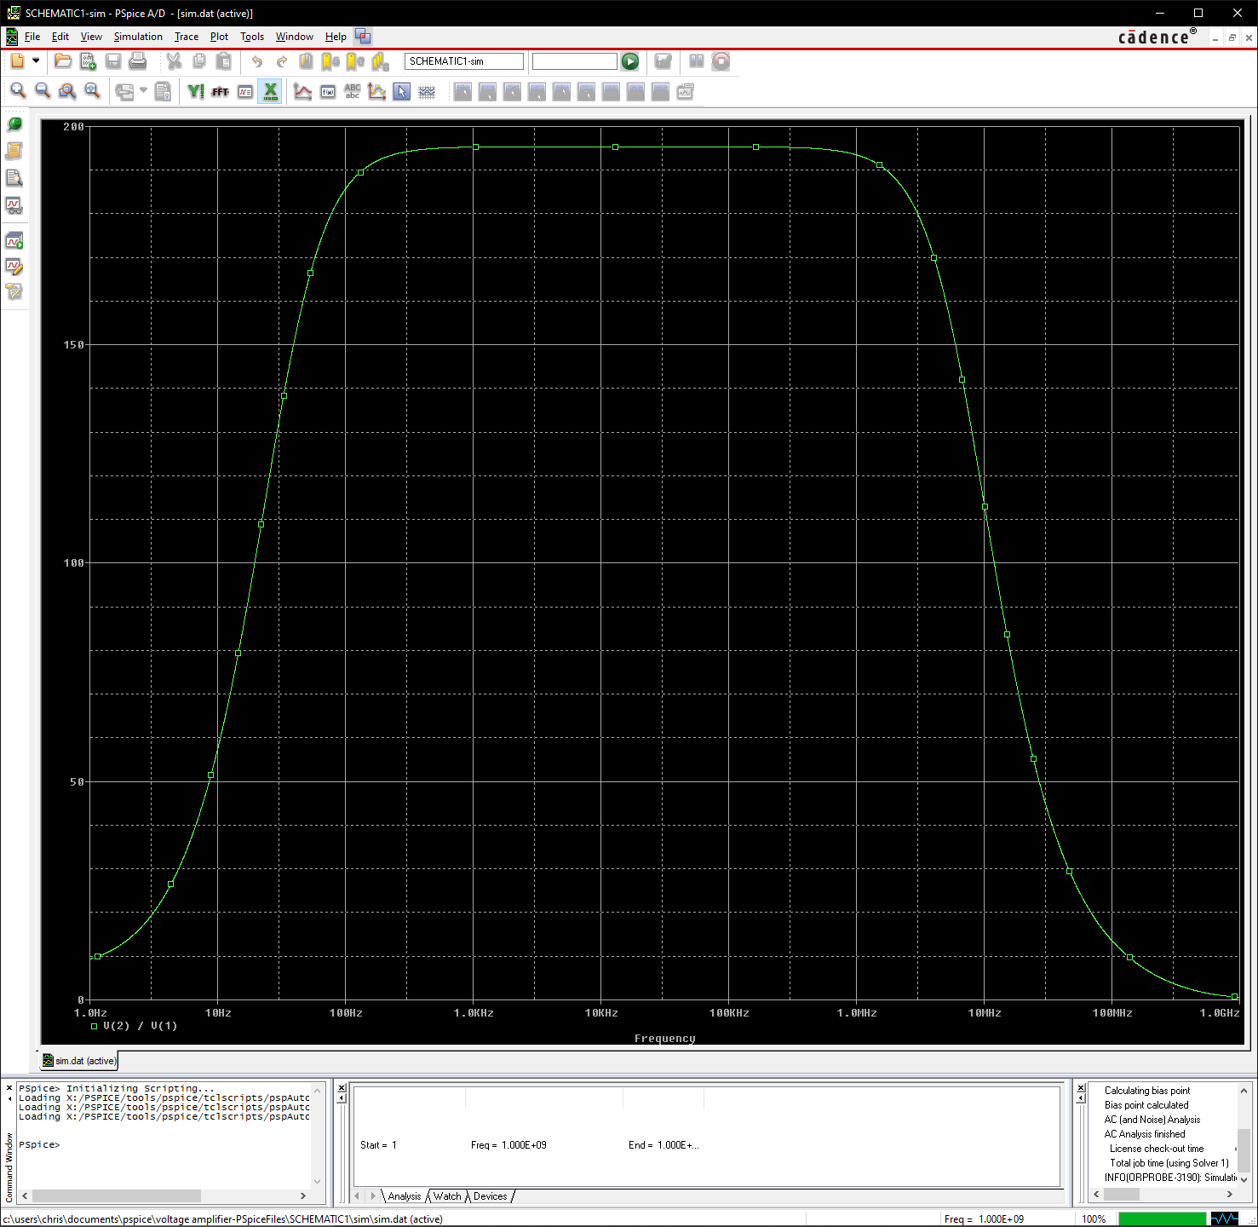

Fig. 12: Voltage Gain of Voltage Amplifier

Even though this gain may seem reasonable, the frequency response is also an important factor, as it must cover the range of human hearing in order for it to be reasonable. Using the equation:

we can see that the crossover frequencies—the bounds of our bandwidth—are at a gain of 138.164. Given that the bounds are at this gain value, we can define our bandwidth, or frequency response range, to be 32.78Hz to 7.154MHz (Bandwidth = 7.15Hz), which covers almost the entire range of human hearing as seen in Fig. 12. With both a reasonable gain and bandwidth, our amplifier meets the requirements for amplifying voltage and, thus, an audio signal with a proper current amplifier connected.

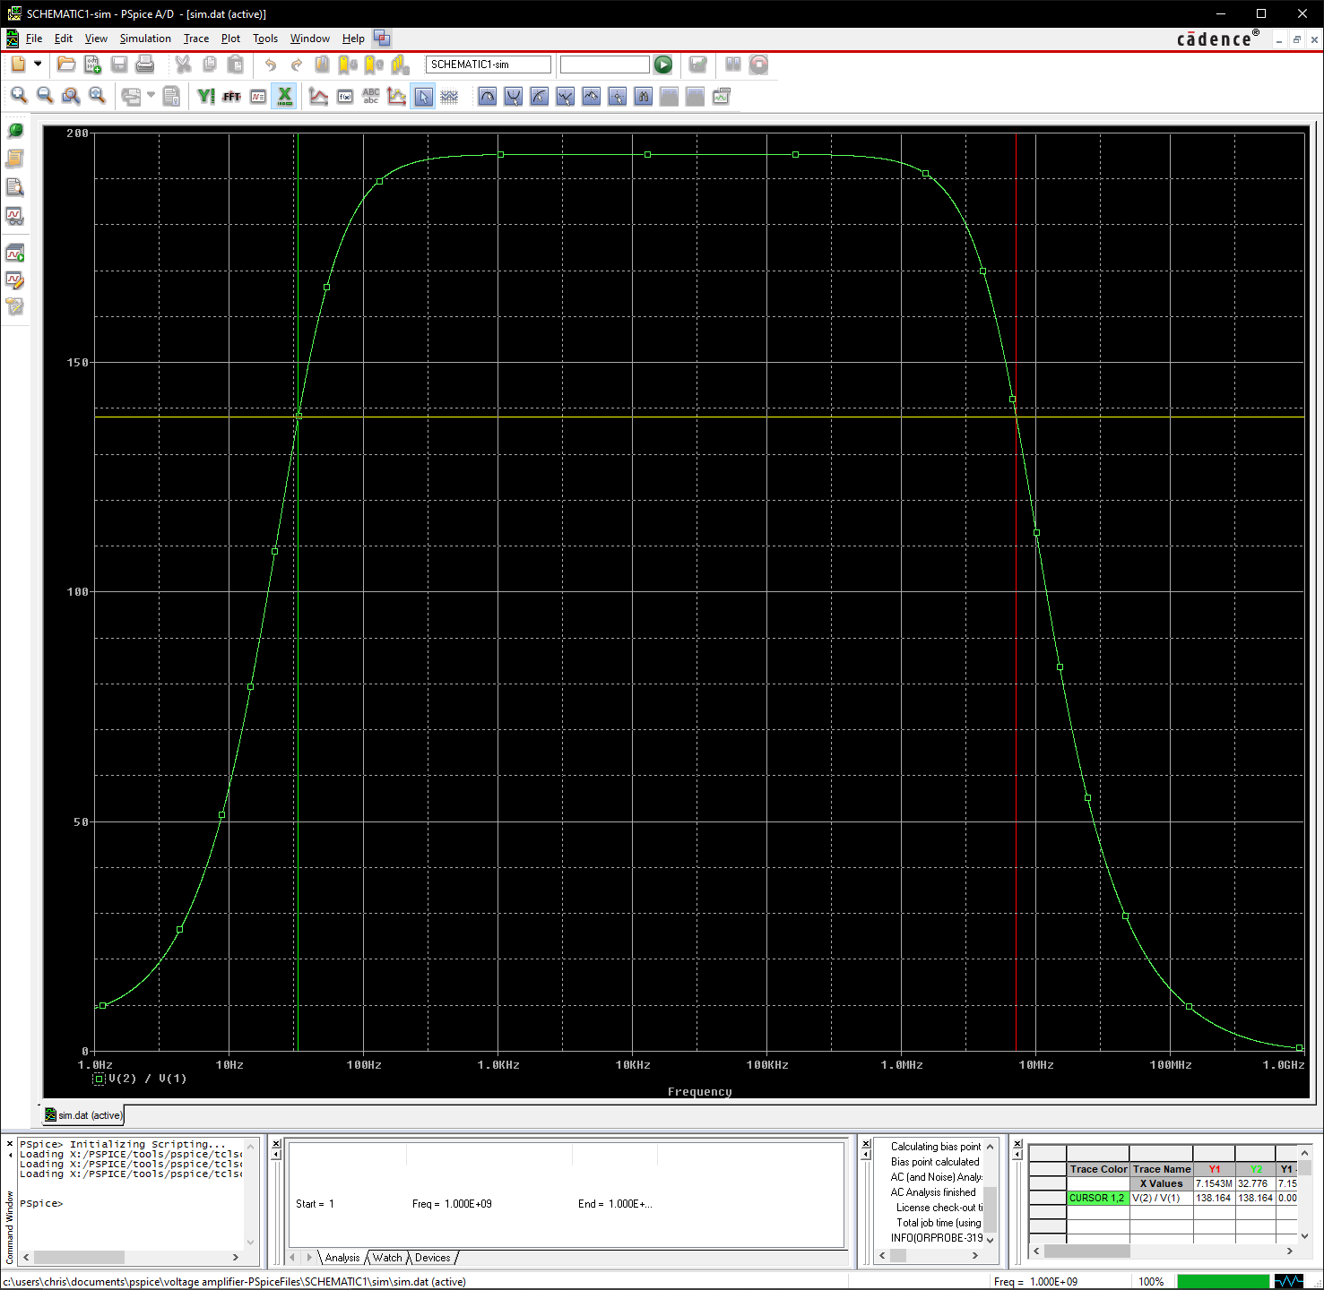

Fig. 12: Voltage Gain of Voltage Amplifier with Bandwidth Displayed Between Two Cursors

# Specifications

## Chosen Components

In addition to circuit design, choosing proper components for the circuit serves just as much as an important role in constructing any circuit. For our amplifier, we decided to value quality over price. Therefore, we decided to use metal film bulk resistors for every resistor in our voltage amplifier. These resistors are preferred when dealing with audio signals as they have less noise due to the metal material they are made from. Additionally, the resistors that we chose have very low tolerances of 0.1%, allowing for us to ensure that our output voltage will not vary between each amplifier built. To accompany these resistors, we also decided to use aluminum electrolytic capacitors which are built specifically with audio in mind. These capacitors are decently priced yet deliver quality sound, as they are known to enhance various aspects of sound such as sharpness, attack and mid-range response.

For our transistor we decided to go with a 2N2222 transistor, as this transistor proved to provide the best gain to bandwidth ratio. This part ended up being the most expensive at $2.34; however, since our circuit only consists of one transistor, the higher price of this item is not too significant. For our input microphone port, we settled on using an XLR input, as these are more widely known to be used by microphones than standard 3.5mm jacks. However, for our output, we used a 2.5mm mono jack, as this size jack will allows us to ensure that consumers do not mistake the port for a headphone input—since most headphone jacks are 3.5mm. Additionally, the size of this jack will allow us to potentially develop a counterpart current amp that has a 2.5mm input, allowing us to directly connect the two amplifiers to form a whole audio amplifier. Also, we chose to use a 9V battery as our DC power supply, as it will be more convenient for user to buy one singular battery as opposed to multiple.

*Note: The microphone we have chosen to use for the amplifier is not included with it in manufacturing, but batteries will be. We chose this microphone for testing purposes, as it is affordable and provides high quality sound. Additionally, it is compatible with our circuit’s XLR input.

## Manufacturing & Price

As noted in previous sections, we have decided to prioritize the quality of our amplifier over the price of it. If we look at Fig. 13 below, we can see that the manufacturing price comes to $11.84. If we consider that manufacturing multiple units will decrease the price of components, we can estimate that our overall manufacturing price will decrease by roughly $1.00—we must also account for the price of manufacturing the board through OSH Park. Additionally, since our amplifier uses high quality parts, we can expect that we will have less faulty units, meaning there will be less money loss due to bad units. Therefore, we can predict that in the long run, we will make a profit on our amplifier along with gain loyal customers. (See Fig. 14 for schematic and layout of potentially manufactured product)

|  |  |
| --- | --- |
| Component | Price |
| Metal Film 300kΩ Resistor | $0.71 |
| Metal Film 3kΩ Resistor | $0.79 |
| Metal Film 100kΩ Resistor | $0.90 |
| Metal Film 400Ω Resistor | $0.90 |
| XLR Input Connector | $1.56 |
| 2.5mm Output Audio Jack | $0.87 |
| Panasonic 9V Battery | $1.85 |
| 9V Battery Snaps & Contacts | $1.15 |
| Aluminum Electrolytic 330µF Capacitor | $0.77 |
| Bipolar Transistor 2N2222 | $2.34 |
|  | **Total: $11.84** |

Fig. 13: Price of Each Component in Voltage Amplifier

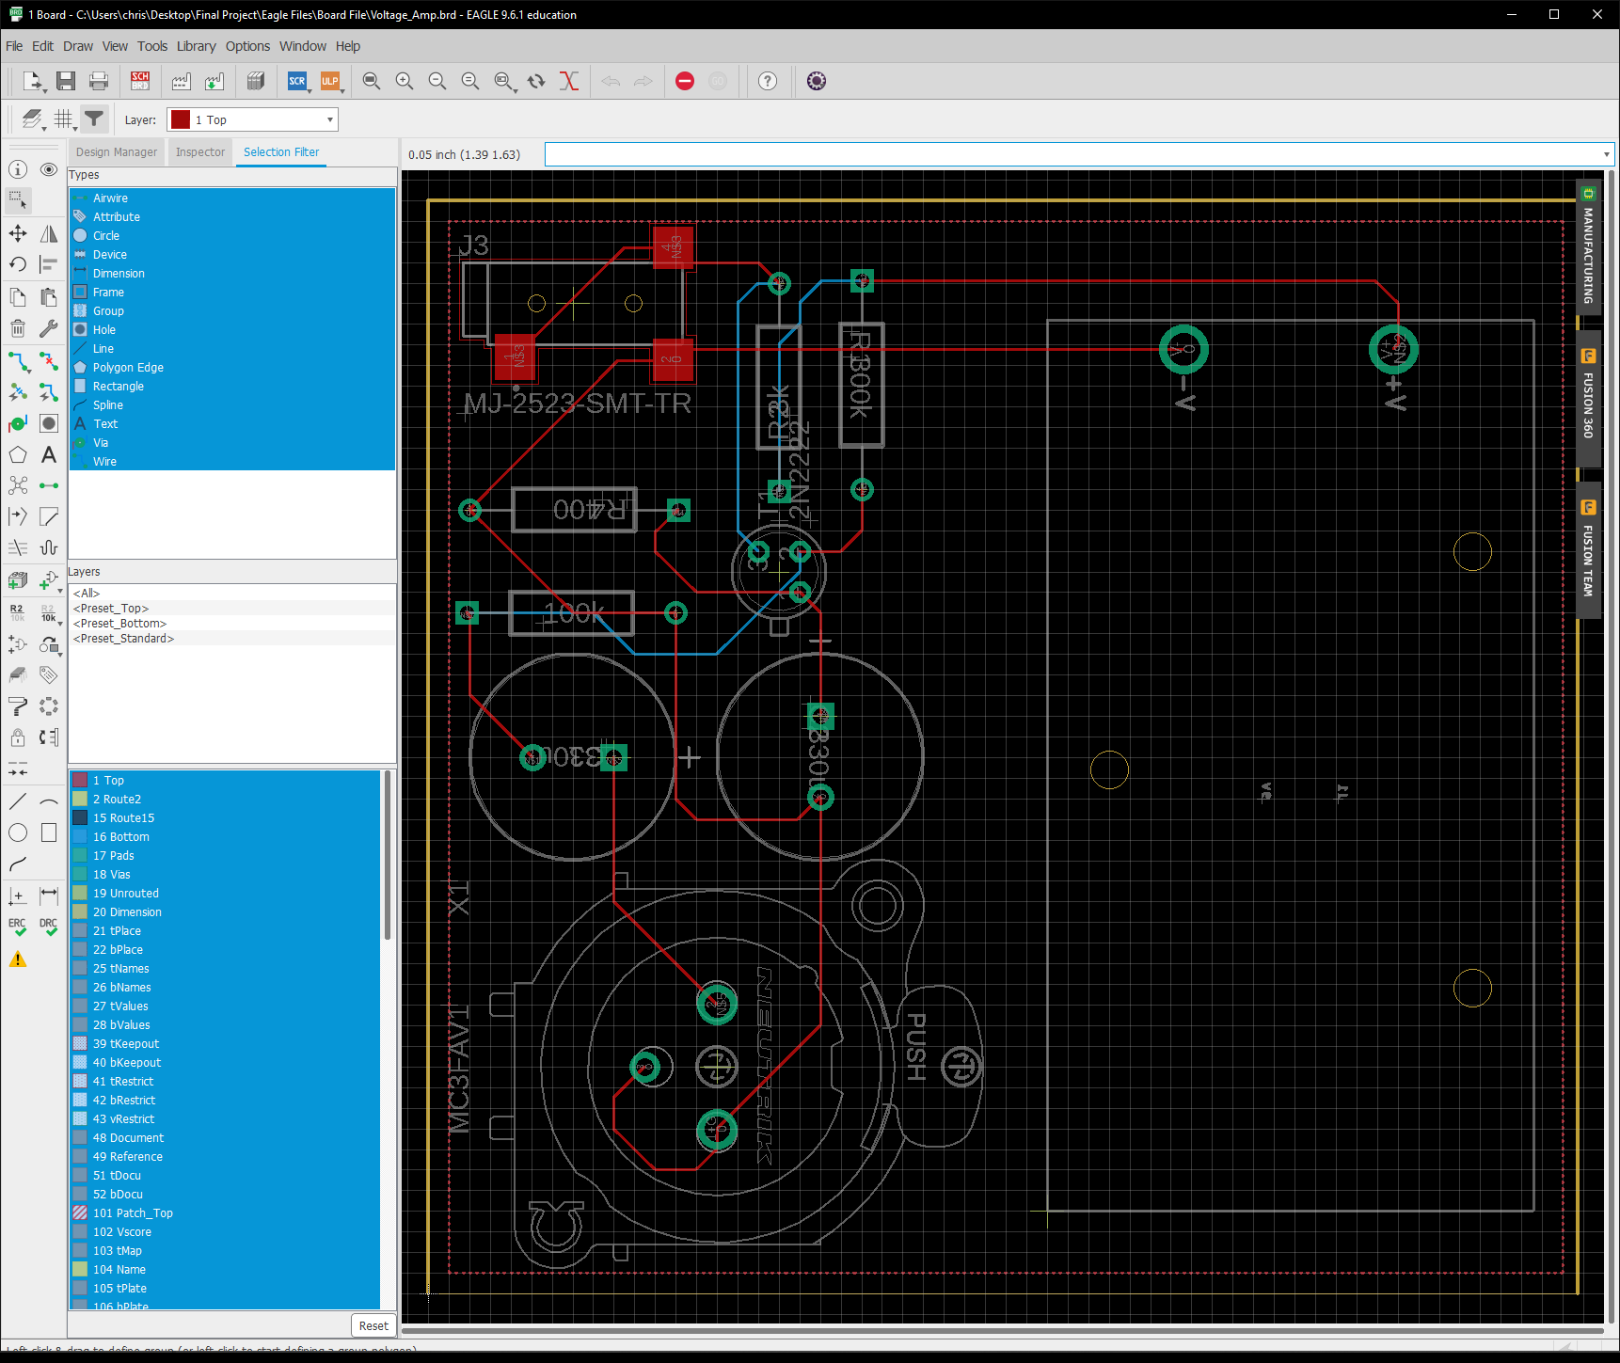

Fig. 14a: PCB Board Layout of Manufactured Voltage Amplifier

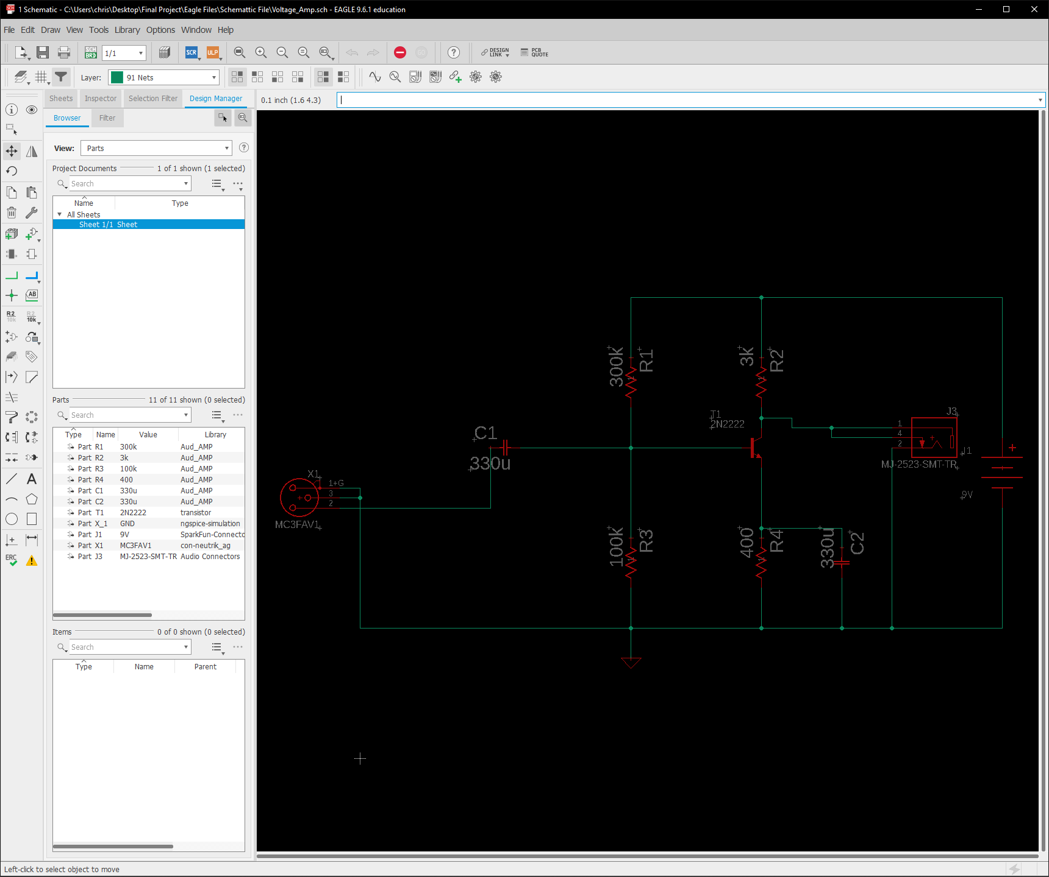

Fig.14b: Schematic of Manufactured Voltage Amplifier

# Conclusion

Although my partner decided to drop the entire project unexpectedly, the overall experience of the project was still fulfilling. Not only did I experience the design process, but I also was able to learn various software tools, i.e. PSPICE, EAGLE, and MATLAB. Experiencing such a process and learning such tools will assist me in both senior design and the real-world of designing and constructing projects. Had I not been able to take such a class, I would never be as confident or prepared for any future project design.

Besides the software tools, I also gained the knowledge of what it takes to design and manage any project. Not only does it take a massive amount of time and planning, but it also requires one to dedicate themselves and put forth effort. Such effort includes a large amount of researching which was a big part of this design project. Being able to take the time to understand the various aspects of my amplifier by conducting research allowed me to not only design my amplifier but also optimize it throughout the process as I gained more info on its functionality.

Given that my partner decided to give up on the class, I am not sure whether I could consider my “team” as having the winning amplifier. Even though I completed my half of the amplifier, the amplifier itself will not be able to amplify an audio signal alone without the assistance of a current amplifier. Therefore, despite having wanted to complete the project and be the winner, I do not have a fully completed audio amplifier. However, in the aspect of voltage amplifiers, I believe that I could potentially have a winning amplifier, as its overall specs are good, and it possesses the quality anyone would desire for a voltage amplifier despite its price.

Given the circumstances that are currently occurring, this semester of TOOLS was rather unorthodox. Despite the unusual conductance of the project, the overall experience was generally good. However, one aspect of the class that could be improved upon to benefit the students is its vagueness in instruction. Throughout the course I always had many questions regarding my amplifier due to unclear directions and instruction. At times I had to make assumptions of what was wanted by certain assignments, as the directions usually were not detailed enough. Aside from that small aspect, the class as a whole was very good and beneficial. By exposing student to the design process early, their knowledge and skills in managing such projects greatly improves, as experience is one of the best ways to learn anything, especially when it is engineering.